 | IQVIATM Work Instruction Statistical Review and Input to a Clinical Trial  Protocol
Document Number and Revision:
CS_WI_BS006 Revision 14
Document Owner:  Carrie Eason |  | Authors:  Gino Colavita

PURPOSE
To describe the statistical input and review of a clinical study protocol in terms of objectives, proposed study design, conduct and statistical methodology.

SCOPE

  - This work instruction (WI) applies to all studies globally which include IQVIA Biostatistics where:
    - Protocol development (including amendments) is undertaken by IQVIA
    - Protocol review is undertaken by IQVIA

ROLES AND RESPONSIBILITIES
The following roles perform tasks described within this WI:

Role | Sections
Statistical Team Lead (STL) | 6.1, 6.2, 6.3, 6.4, 6.5
Experienced Biostatistician (EB) | 6.1, 6.2, 6.3, 6.4, 6.5
Senior Biostatistical Reviewer (SBR) | 6.1, 6.3, 6.4

DEFINITIONS

Experienced Biostatistician:
In the absence of an assigned and/or suitably experienced STL, a suitably experienced Biostatistician assigned to apply specific statistical or therapeutic area knowledge to a defined scope of work (e.g. protocol writing). The EB must be capable of managing challenging discussions with the customer.

ACCCA:
Accuracy: free from error or defect; correct.
Consistency: not self-contradictory; coherent.
Clarity: easily understood without ambiguity, excess verbiage or redundancy; comprehensible; free from confusion, uncertainty or doubt; effective layout allows for easy understanding (e.g. bullets, indentation).
Completeness: all parts/elements addressed; lacking nothing; fully detailed.
Appropriateness: suitable of fitting for a particular purpose.

MATERIAL AND EQUIPMENT
Not Applicable.

PROCEDURE

  - Protocol Considerations

No: | Who: | Step: | When:
6.1.1 | STL/EB/ SBR | Contributes to the protocol (or amendments) taking the following into consideration:  - Relevant regulatory guidelines (e.g. Food and Drug Administration [FDA], European Medicines Agency [EMA])  - International Council for Harmonisation (ICH) guidelines: E3, E6, E9 and others as appropriate  - Guidelines relating to the study’s therapeutic area and/or indication  - Relevant literature  - Clinical development plan  - Similar studies and programs  - Summary basis of approval for similar compounds  - Approaches to QC (QC) (CS_WI_BS015) and Approaches to QC: Appendix A – QC of the Protocol (CS_OD_BS0225)  - Preparation and Review of CP-generated Documents (PI_WI_PK0210) for studies including Early Clinical Development biostatistics support | During protocol authoring and review

  - Statistical Contributions to Protocol

No: | Who: | Step: | When:
6.2.1 | STL/EB | Contributes to the preparation of sections of the protocol (or amendments) in compliance with Producing a Clinical Study Protocol (CS_WI_MW006) or Producing a Clinical Study Protocol Amendment (CS_WI_MW0236) which relate to:  - Study design, including sample size  - Collection, management, analysis, and statistical reporting of data | During protocol authoring
6.2.2 | STL/EB | Authors sections of the protocol or provides information to the Lead Medical Writer (MW) to author the relevant sections. If writing sections of the protocol, the STL/EB must:  - Author text in manner that complies with the ACCCA definition  - Follow any customer style requirements provided by the Lead MW  - Follow the protocol template provided by the Lead MW  - Format the newly written sections by using the predefined MS Word styles that are in the template provided by the Lead MW | During protocol authoring

No: | Who: | Step: | When:
6.2.3 | STL/EB | If included in scope of work, calculates the sample size based on the assumptions provided by the customer or medical team or historical data such as from one or more prior studies completed at IQVIA or as available in literature.  Otherwise verifies sample sizes using the parameters and methods described in the sample size section.  Archives programs and outputs for sample size calculations in compliance with Trial Master File (TMF) (CS_OP_TMF0007) and Management and Filing of Biostatistics Documentation (CS_WI_BS0237). | During protocol authoring
6.2.4 | STL/EB | Arranges internal senior biostatistical review and consolidation of the written protocol sections. | During protocol review

  - Statistical Protocol Review

No: | Who: | Step: | When:
6.3.1 | STL/EB/ SBR | Comments freely on all aspects of the protocol, in compliance with Producing a Clinical Study Protocol (CS_WI_MW006) or Producing a Clinical Study Protocol Amendment (CS_WI_MW0236), as applicable. Consider the checks included in the Approaches to QC: Appendix A – QC of the Protocol l (CS_OD_BS0225) when performing the review. | During internal review cycle
6.3.2 | STL/EB | Documents review in a Reviewer Feedback Form (CS_FM_BS007). | After the protocol has been reviewed
6.3.3 |  | Signs the Internal Signature Page for Medical Writing Deliverables (CS_FM_MW007) or corresponding customer form, as evidence of the completed protocol review. | When requested by the Lead MW
6.3.4 |  | Attends review meetings. | When requested
6.3.5 | SBR | Reviews any sections of the protocol written by the STL/EB, as specified in Approaches to QC (CS_WI_BS015). | During internal review cycle
6.3.6 |  | Performs QC on any sample size determinations in compliance with Approaches to QC (CS_WI_BS015), when performed by IQVIA.
6.3.7 |  | Documents review (including sample size) in a Reviewer Feedback Form (CS_FM_BS007).
6.3.8 | STL/EB | Forwards one set of consolidated statistical comments, preferably as MS Word tracked changes (annotated protocol), to the Lead MW. | During internal review cycle

  - Statistical Considerations

No: | Who: | Step: | When:
6.4.1 | STL/EB/ SBR | Verifies that the protocol contains statistically valid statements in sufficient detail for each of the following areas, as relevant for the study:  - Objectives of the study are stated clearly in terms of endpoints and hierarchy of priorities  - Efficacy and safety endpoints reflect accepted norms in the relevant field  - Endpoints are validated by earlier studies or literature  - Suitability of the study design in terms of the study and program objectives, nature of the disease, endpoints, practical constraints (e.g. availability of subjects) and efficiency (i.e. exposure of as few subjects as possible)  - Relevant literature and applicable regulatory guidelines  - Inclusion and exclusion criteria (including subject re-entry details)  - Treatment assignment (randomization, stratification), if applicable, and means of maintaining and breaking the blind (in emergencies)  - Patient measures or findings which could lead to indirect unblinding are clearly identified  - If not blinded, reasons and means of minimizing bias  - Methods for determining sample size  - Assumptions on which sample size estimates are based (e.g. response rates from previous studies, variability, decision criteria)  - All necessary details for recalculation and verification of sample sizes using the parameters and methods described in the sample size calculation section  - Stopping rules are clearly specified and justified in terms of the study objectives  - Method of data collection and timing: verifies that the data are relevant, meaningful, reliably measured, with sufficient precision and at appropriate intervals; unnecessary data is not collected  - Information on planned interim analyses to compare treatment arms for efficacy or safety, either formal; including details on any planned Data Monitoring Committee or informal; methods to maintain study integrity  - Adjustments of the Type I error rate for a planned interim analysis  - Details of hypotheses, decision criteria and significance levels  - Details on the estimation of parameters and planned comparisons or contrasts  - Methods to account for multiplicity  - Rules to determine subject evaluability (with respect to analysis sets), especially in cases of protocol deviation, intercurrent events, withdrawal or dropout | During protocol drafting and review

No: | Who: | Step: | When:
- Methods for handling or imputing missing data
- Suitability of the data captured, and proposed analysis to meet the study and program objectives
- General strategy for dealing with each type of data (e.g. demographic and background characteristics, compliance, efficacy, safety)
- Statistical methodology to be used for primary, secondary and other analyses
- Definition of any relevant estimands and any impact on study design
- Use of alternative approaches in the event the data violates statistical assumptions
- General accuracy and consistency within and between sections of the protocol
- Factors or data that are relevant to quality management of the study
- Any other statistical factors relevant to the study. Issues will vary from study to study. The above list is not comprehensive

  - Documentation

No: | Who: | Step: | When:
6.5.1 | STL/EB | Files Reviewer Feedback Form (CS_FM_BS007) in compliance with Trial Master File (TMF) (CS_OP_TMF0007) and Management and Filing of Biostatistics Documentation (CS_WI_BS0237). | After review is complete

- SUPPORTING DOCUMENTATION
DOCUMENT NUMBER | TITLE
ESOP References
7.1 CS_FM_BS007 | Reviewer Feedback Form
7.2 CS_FM_MW007 | Internal Signature Page for Medical Writing Deliverables
7.3 CS_WI_BS015 | Approaches to QC
7.4 CS_WI_MW006 | Producing a Clinical Study Protocol
7.5 CS_WI_MW0236 | Producing a Clinical Study Protocol Amendment
7.6 CS_OP_TMF0007 | Trial Master File (TMF)
7.7 CS_WI_BS0237 | Management and Filing of Biostatistics Documentation
7.8 PI_WI_PK0210 | Preparation and Review of CP-generated Documents
7.9 CS_OD_BS0225 | Approaches to QC: Appendix A – QC of the Protocol
External References

DOCUMENT NUMBER | TITLE
7.10 ICH E3 | Structure and Content of Clinical Study Reports
7.11 ICH E6 | Guideline for Good Clinical Practice
7.12 ICH E9 | Statistical Principles for Clinical Trials

- SUPERSEDES
DOCUMENT NUMBER | TITLE | REVISION NUMBER
8.1 CS_WI_BS006 | Statistical Review and Input to a Clinical Trial Protocol | 13

- MODIFICATION FROM PREVIOUS REVISION
CHANGE | SECTION REFERENCE | JUSTIFICATION
Updated minor spelling and grammatical issues | All | Improve clarity and consistency
Updated reference from Management of Trial Master File (CS_OP_RM0296) to Trial Master File (CS_OP_TMF0007) and Management and Filing of Biostatistics Documentation (CS_WI_BS0237). | 6.2.3 and 6.5.1 | Previous document obsolete. Replaced with two new documents.
Title of CS_WI_MW006 updated to “Producing a Clinical Study Protocol” and reference added to sections | 6.2.1 and 6.3.1 | Document name change
Added reference to Producing a Clinical Study Protocol Amendment (CS_WI_MW0236) | 6.2.1 and 6.3.1 | New document
Added reference to CS_OD_BS0225 (Approaches to QC: Appendix A – QC of the Protocol) | 6.3 | To be used in internal protocol review process
Added reference to ICH E6 to list of external references | 7 | Mentioned in Section 6.1.1
Deleted Section 6.5, Working with Medical Writing (if IQVIA writes the protocol) | 6.5 | CS_WI_MW006 and CS_WI_MW0236 already references in sections 6.2.1 and 6.3.1, and contain all required information.

- APPENDICES

  - Appendix A: Protocol Review and Input Workflow

Appendix A: Protocol Review and Input Workflow
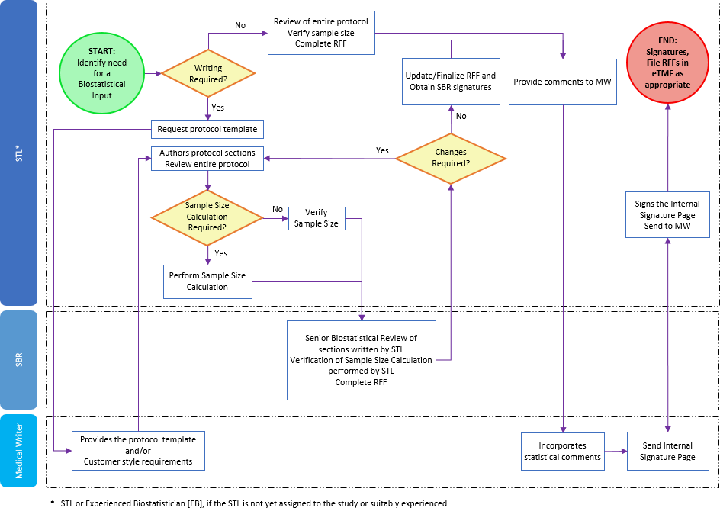

Page 8 of 8
Copyright © 1999, 2000, 2003, 2006, 2008, 2010, 2011, 2013, 2015, 2017, 2019, 2022 IQVIA. All rights reserved. The contents of this document are confidential and proprietary to IQVIA Holdings Inc. and its subsidiaries. Unauthorized use, disclosure or reproduction is strictly prohibited.

Standard Operating Procedure Approval Signature(s)
This is a representation of an electronic record that was signed electronically in Content Server.
This page is the manifestation of the electronic signature(s) used in compliance with the organization’s electronic signature policies and procedures
Refer to Signatories CV for Business Title.

UserName: Willmott, Corinne (q778849) Title:
Date: Wednesday, 09 February 2022, 11:30 AM Eastern Time Meaning: Signing this Document Indicates My Approval
================================================

UserName: Bickford, Emma (q637065) Title:
Date: Thursday, 10 February 2022, 04:08 AM Eastern Time Meaning: Signing this Document Indicates My Approval
================================================

